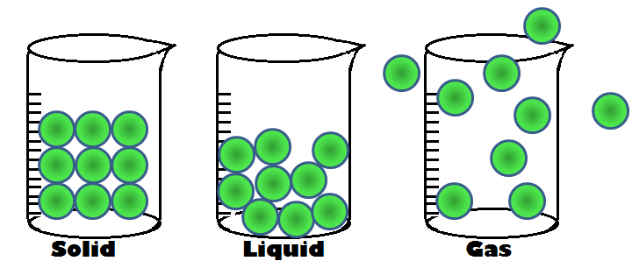
States and Properties of Matter
Study Guide
Quiz Tuesday, October 2nd
Be familiar with the meanings of these words:
Matter is anything that takes up space.
A solid has a definite shape and takes up space.
Liquids pour easily and take the shape of their container.
A gas has no size or shape and fills up the space it is in.
A property of matter is something that can be known by looking at or feeling the matter. (size/shape/color/texture)
Can you list examples of solids, liquids, and gases?
solid | liquid | gas
What properties can be used to describe the picture? log
long | hard | smooth | big
short | soft | rough | small

Can you describe the properties of an item inside your house?
States and Properties of Matter
Study Guide
Quiz Tuesday, October 2nd
Be familiar with the meanings of these words:
Matter is anything that takes up space.
A solid has a definite shape and takes up space.
Liquids pour easily and take the shape of their container.
A gas has no size or shape and fills up the space it is in.
A property of matter is something that can be known by looking at or feeling the matter. (size/shape/color/texture)
Can you list examples of solids, liquids, and gases?
solid | liquid | gas
What properties can be used to describe the picture? log
long | hard | smooth | big
short | soft | rough | small

Can you describe the properties of an item inside your house?

