STUDY GUIDE : Maps, Globes, and Landforms
Quiz: Tuesday, October 30th

Compass rose- a symbol that shows cardinal directions
Map key- a part of a map that describes the meanings of symbols
Globe- a round model of the Earth
Map- a drawing of a real place seen from above
Symbol- a small picture that stands for something else
Landforms- natural features of Earth’s landscape
Where do I live?
Planet : Earth 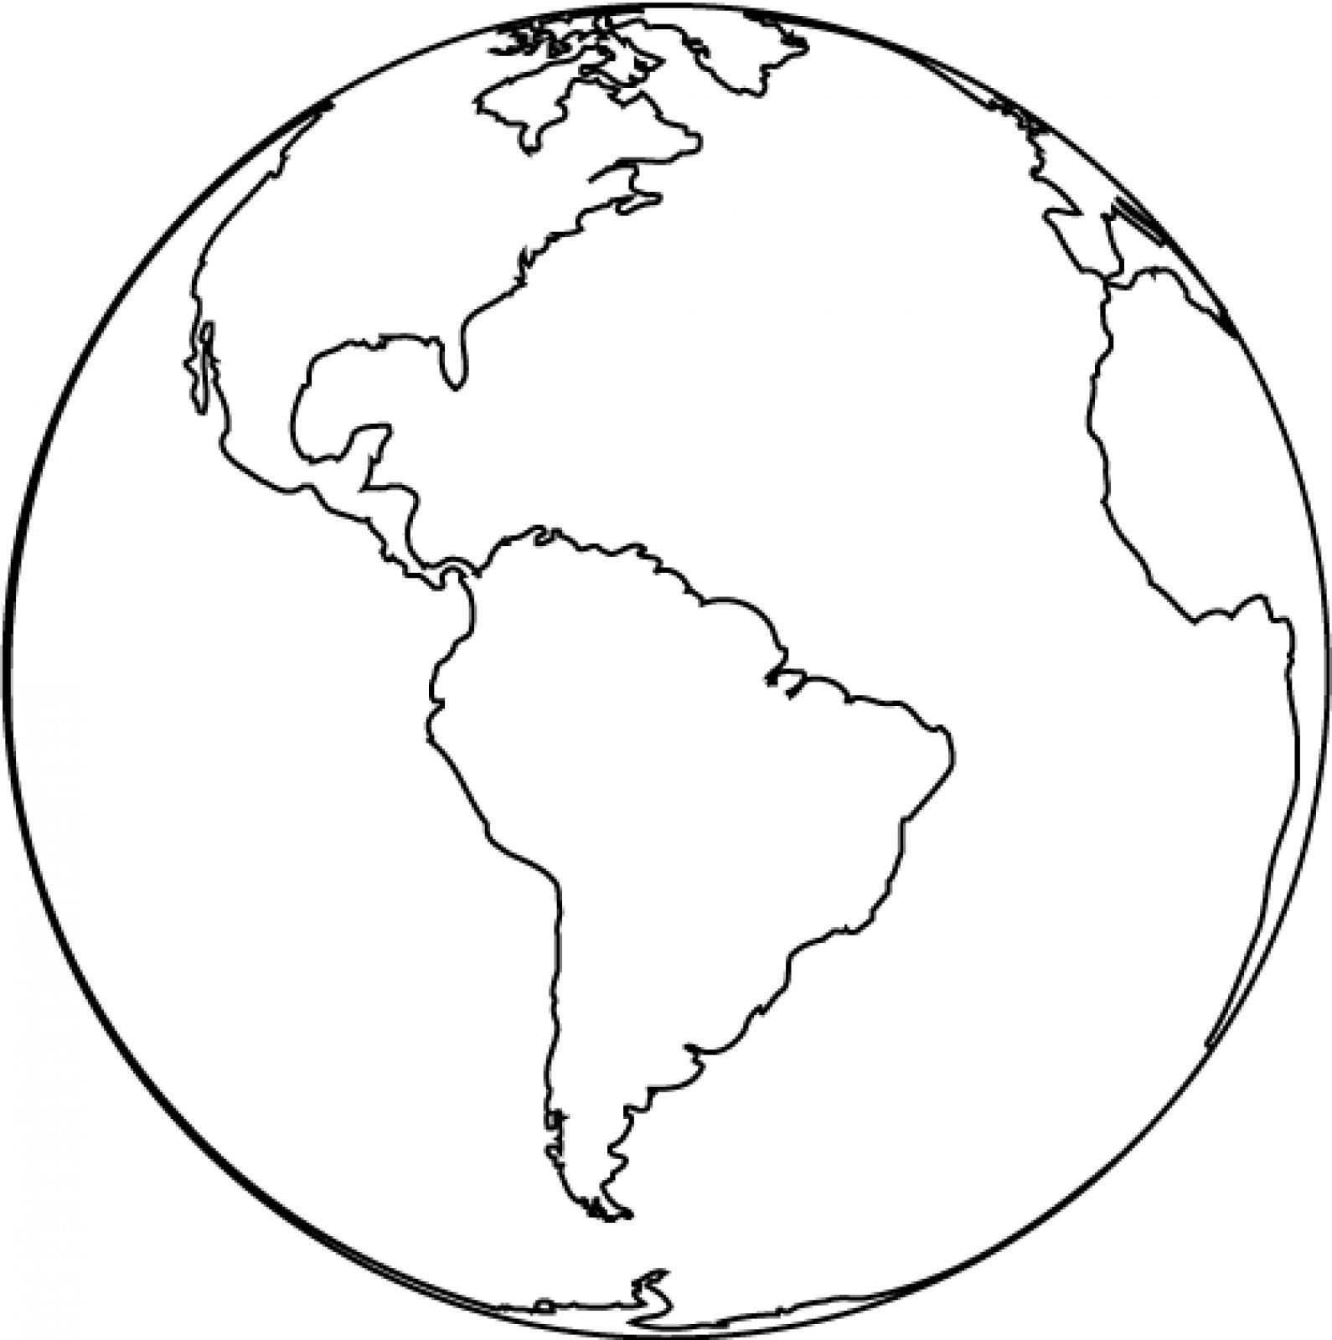
Continent: North America 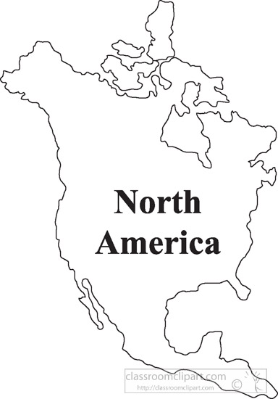

Country: United States of America 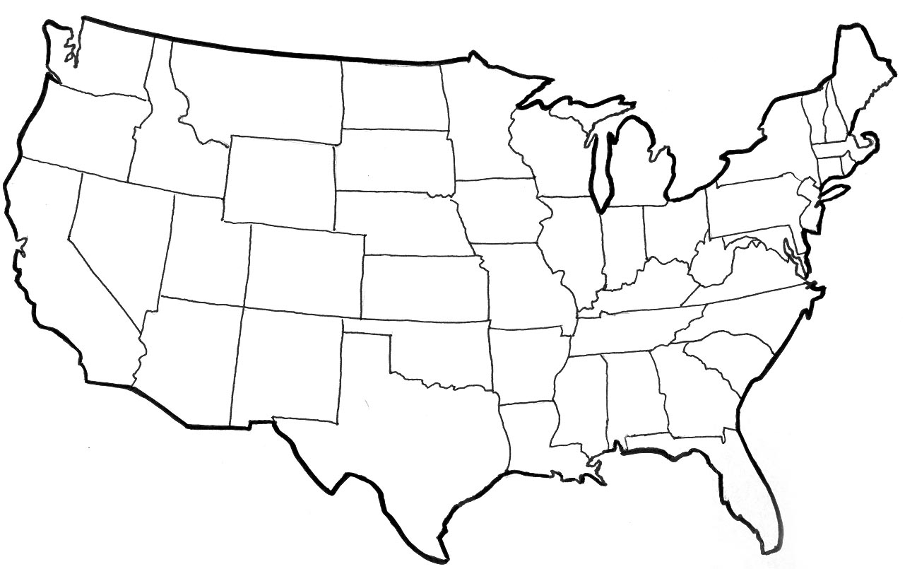
State: Louisiana 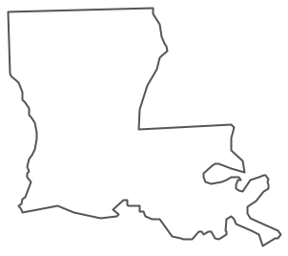
City: Baton Rouge

(Remember: Never Eat Squiggly Worms)

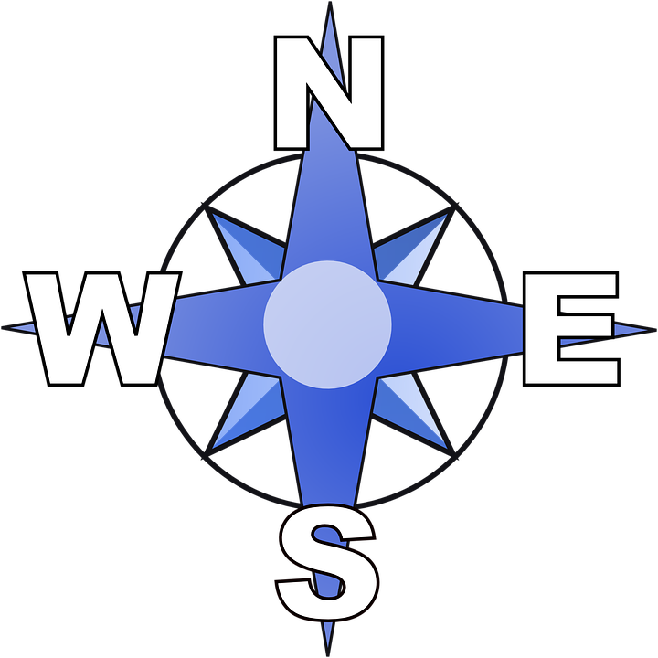

N = north
E= east
S= south
W= west

Water and Landforms
A hill is higher than other land and has a rounded top
A mountain is higher than other land and usually has a peak
A lake is a body of water with land all around it
A river is a long body of water that flows across land
An ocean is a large body of salt water
A valley is the low area between two mountains or hills
An island is land with water all around it
A plain is flat land

